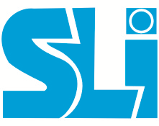

Sri Lakshmi Industries
(An ISO 9001:2015 Certified Company)
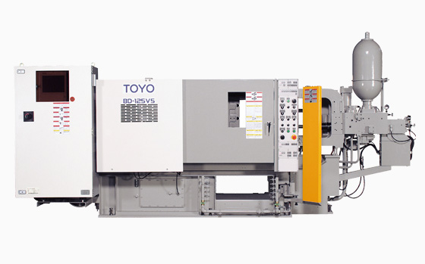Horizontal Cold Chamber Pressure Die Casting
Fettling, Shot Blasting, Vibro & machining

Visit/Contact us @ Plant Location:
No.99/10, SIDCO Industrial Estate, Thirumudivakkam, Chennai – 600044.
Phone: 044-, Email: srilakshmi.industries@yahoo.com.

f
About SLI…

Sri Lakshmi Industries (SLI) is a Partnership firm established during May 2008. The firm is current engaged in the process of shot blasting of aluminium castings on job work basis. The firm has proposed to start manufacture of aluminium and aluminium alloy pressure die casting components on job work basis. Towards this objective, the firm has identified the machineries and the same would be installed in the exiting factory of the firm at Thirumudivakkam.
Mr. Ramalingam and Mr. Manoj are the Partners of the firm. Both the partners are actively involved in the daily affairs of the firm. Mr. Manoj is an Engineering Graduate with EEE specialization from the Kerala University. Mr. Ramalingam is a Graduate with specialization in Business Administration from the Annamalai University. Both the partners have 10 years of experience in the same field. With the experience and hard-work the Partners are confident of achieving constant growth levels in the years to come.

Quality Management System...

SLI is an ISO 9001:2008 certified organization that to measure and improve our customer satisfaction by understanding all our customer requirements and we have a team of professionally qualified staff and experienced work force to manufacture high quality products. A well established quality team is strict adherence to quality control measures in our supply chain (supplier end – SLI Line - customer end) to assure consistent product quality by maintaining 100PPM at all our customer end.
QUALITY POLICY

Sri Lakshmi Industries is committed to achieve to Customer satisfaction by meetings applicable requirements supplying quality products on time and consistently by practicing effective quality management system and continual improvement.
QUALITY OBJECTIVES

- Effective utilization of Man, Machine and Materials.
- Aim for 100% Delivery Performance
- Improve Supplier Performance
- Aim for achieving Zero customer complaints

SLI commitment to quality is unfaltering and makes it products in accordance with the international norms. Customised testing or dimensioning programs are implemented as required by the customer.

Products…
Our process of product engineering allows us to mesh the talent of our people with the latest technologies to yield a robust manufacturing design that will deliver product to our customer which;
- Meets and/or exceeds their performance expectations
- Minimizes their time to market
- Reduces defects PPM in our supply chain
- Reduces their cost

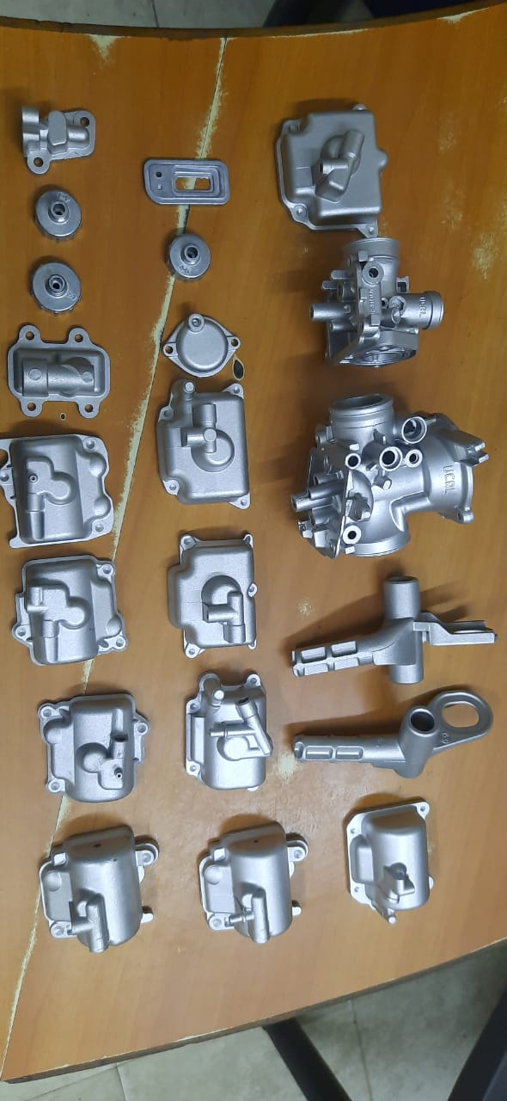

Machinery Specification Details.....
SLI is well equipped with machinery to manufacture components with pressure die casting, machining and finishing processes like shot blasting, fettling, Trimming, Vibro finishing etc.

Horizontal Cold Chamber Pressure Die Casting Machine TOYO 125 v4 and 120 SS ENGINEERING
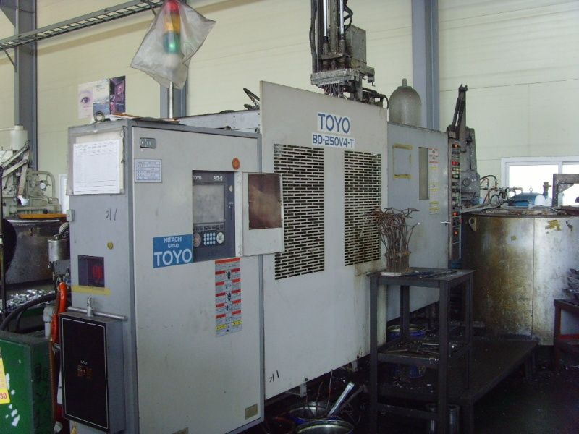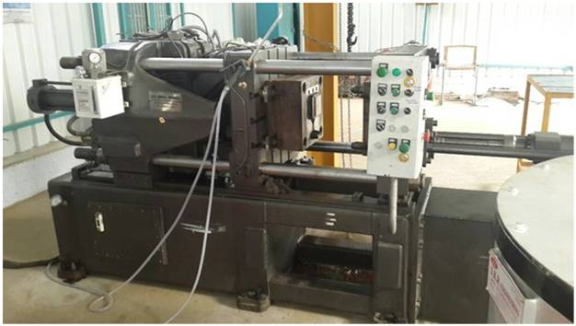

Horizontal Cold Chamber Pressure Die Casting Machine TOYO AND ZITAI

Machine bases extra strong structural construction, which supports the injection system on its extension. Part of the base is attached with oil reservoir to accommodate a good quantity of hydraulic oil and is provided with oil gauge and digital thermometer.
Salient Features:
1, Auto laddle
2, Auto spray
3, Extractor
2, Powerful 3 Stage Injection
3, Independent Hydraulic Arrangement to Centre and Bottom Injection Quick Shifting

Shot Blasting machine Thumblast Type, Chamber Size: 20”x27”
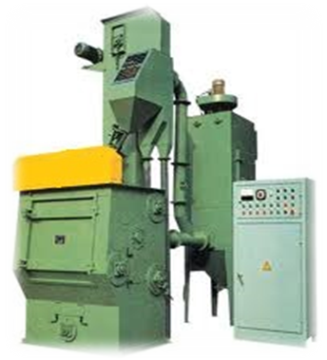
Shot Blasting is a surface finishing technique that involves rapidly impacting the surface of an object with a controlled stream of abrasive shot material. It is faster and more effective than filing for removing flash that may remain on a part after the casting or stamping process.
Shot Blasting is also used for removing burrs, scale, and rust that may interfere with the part’s integrity, appearance, or definition, and it can also prepare the surface of a part for coating by removing surface contaminants and provide a surface profile for increased coating adhesion.

Special Applications of our Shot Blasting Machines:
- Aesthetic Finishing of Die Casting of Aluminium, Zinc Alloy
- Desanding & Discaling of Castings and Forgings
- Preparation of Surface for Protective Coating
- Removal of Heat Treated Scales

Vibro finishing machine 120 Ltr

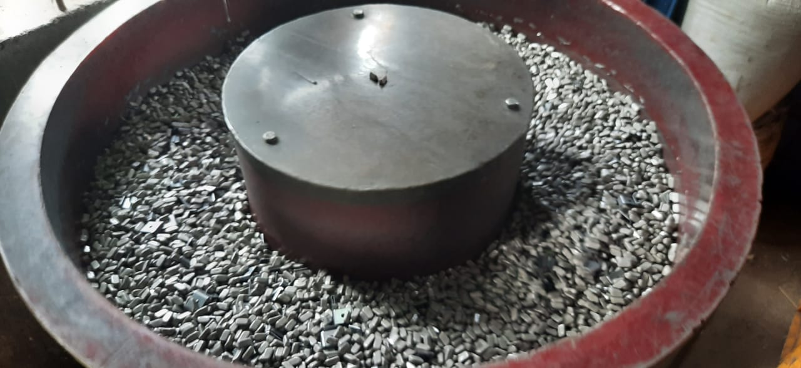

Introduction
Vibratory Finishing Machines are mass finishing machines, used for deburring, polishing, descaling, and surface improvement on metal and plastic components.
Working Principle
The machine has a steel bowl lined with polyurethane which is filled up with required media (either ceramic, plastic, maize etc. depending upon the finish required) and components. Eccentric weights are mounted on an extended shaft attached to a heavy duty motor to cause vibrations and create a spiral of the media and the components. Variations in vibration, achieved by varying weights and angles, and suitable combination of media enable machine to be used for different components.

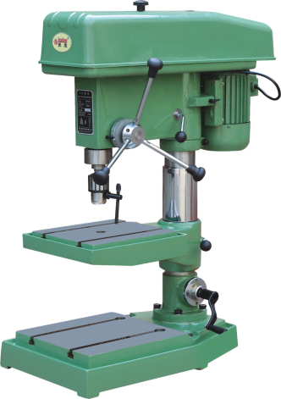
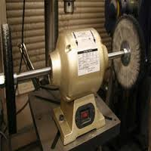
Buffing Machine
Vertical Drilling Machine
Drill Dia: 1 – 37mm
Length : 100mm
RPM: 600/900/1200/1400
FEED: Manual
Specification:
3 Hp motor capacity
Two side shaft
RPM: 2800

DRILL TAP CENTRE

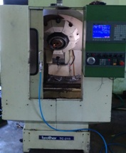
We offer our clients VMC Machine Job Work. Our range finds applications in automobile industries and is used for drilling, milling and other special engineering processes.

CNC MACHINE-1

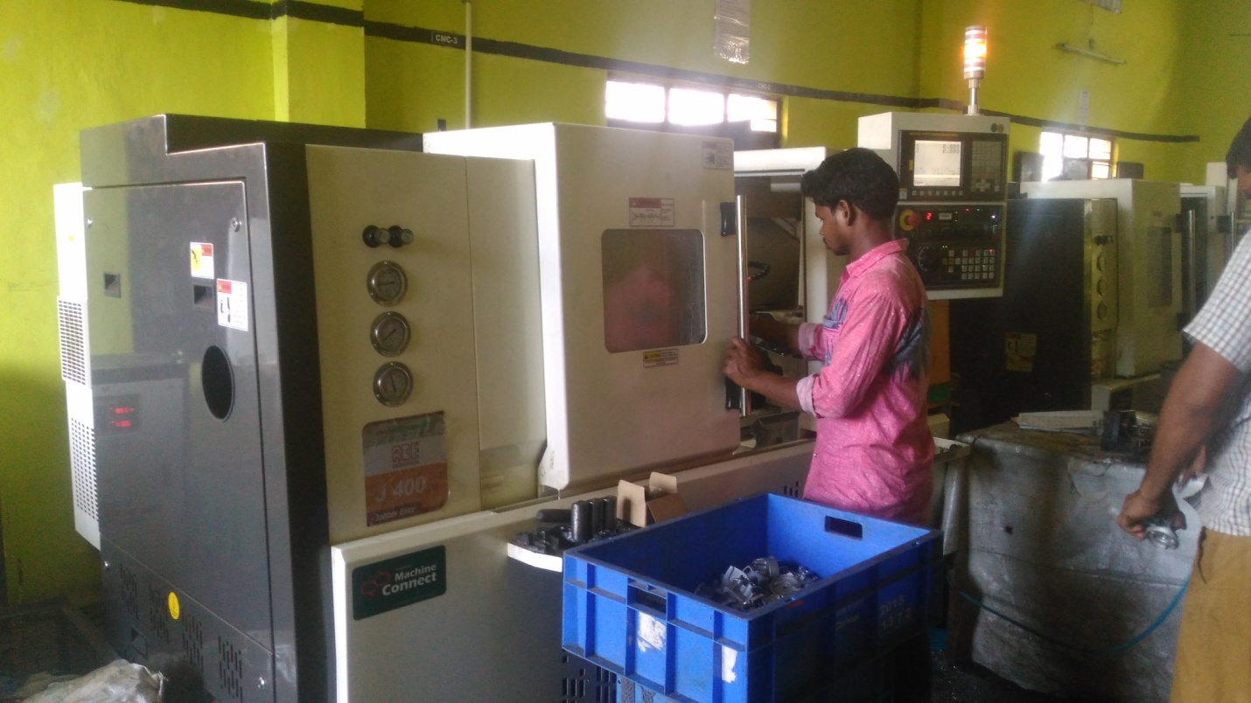

CNC MACHINE-2

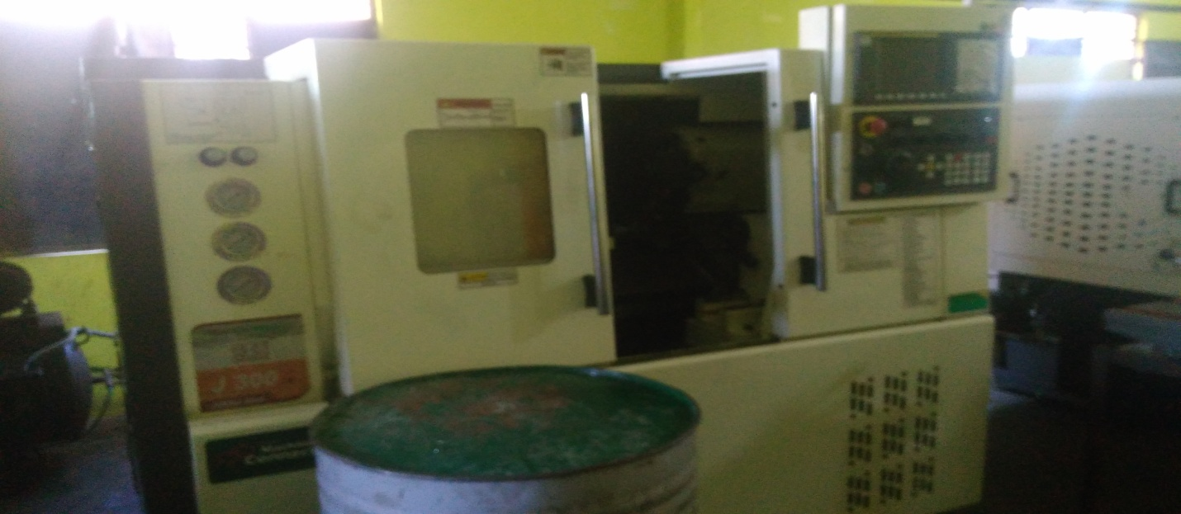

CNC MACHINE-3
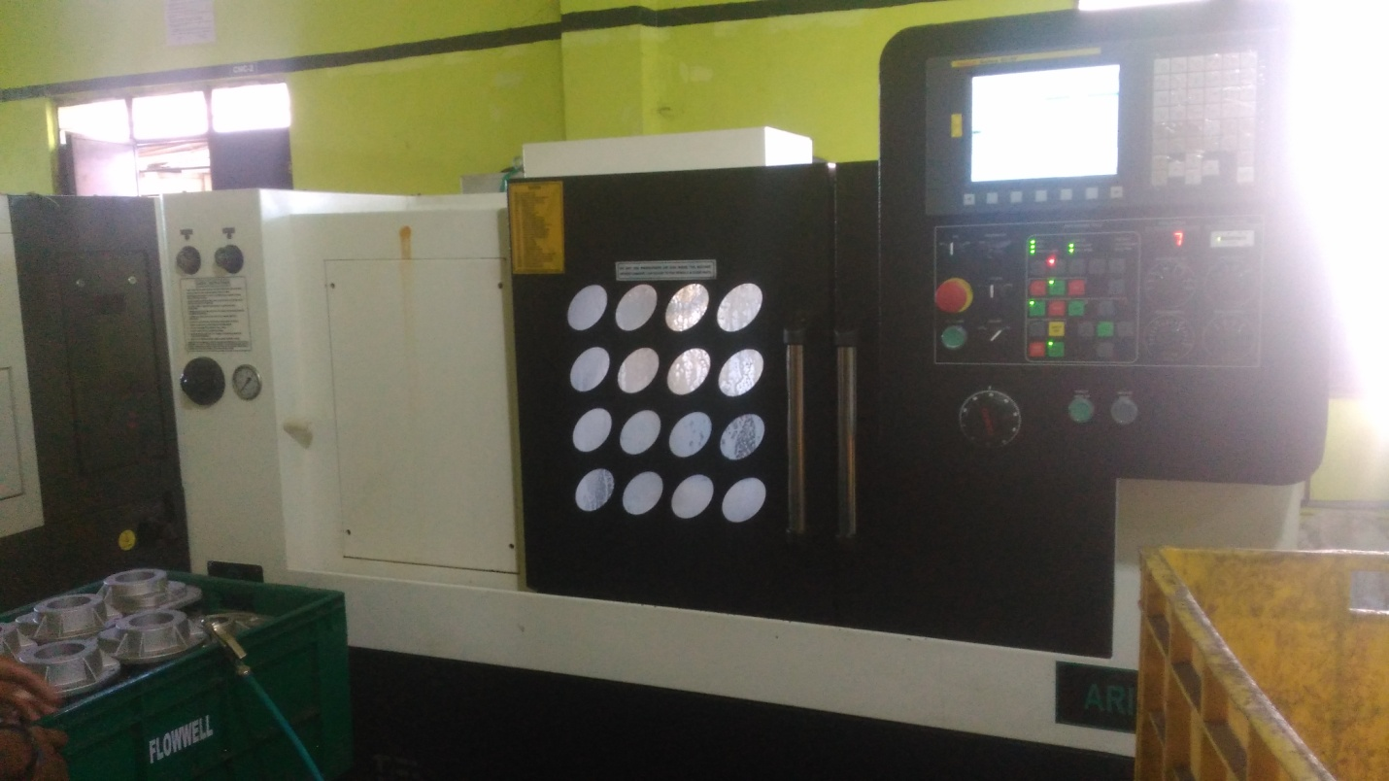

With the assistance of skilled and dedicated professionals, we offer qualitative range of CNC Job Works. Our entire services are widely acclaimed among the clients for its timely execution and flexible approach.
VMC MACHINE

Features:
- Job work for several engineering components and auto components
- Require high precision CNC turning
- Length up to 200mm

M1TR, DRILLING & TAPPING MACHINES
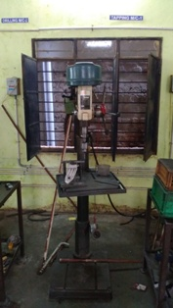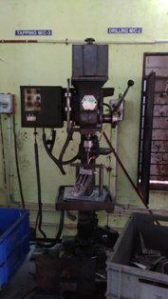

KTK Tapping machine

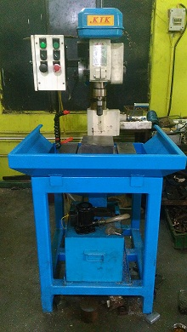

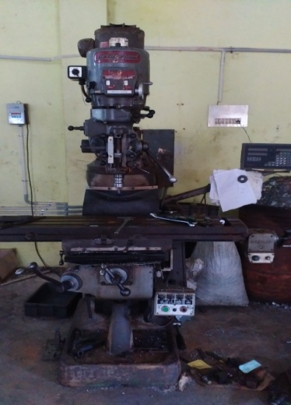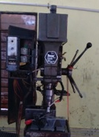
M1TR-MILLING M/C TAPPING M/C

Machinery list...
Machine | Make | Tonnage and Specification
Pressure die casting | TOYO JAPAN 125 | 125 Ton
Pressure die casting | TOYO JAPAN 125 | 125 Ton
Pressure die casting | ZITAI JAPAN | 150 Ton
Pressure die casting | TOYO JAPAN | 350 Ton
Pressure die casting | TOYO JAPAN | 350 TON
Pressure die casting | TOYO JAPAN | 350 TON
Shot Blasting | JA ENGINEERING | 36 X 36
Shot Blasting | PATEL | 20 X 27
Hydraulic Trimming machine | SLI | 5 Ton
Hydraulic Trimming machine | VELAN | 5 Ton
Hydraulic Trimming machine | VELAN | 5 Ton
Drilling Tapping machine |  | 2 hp
Vibro Finishing machine |  | 90 ltrs
CNC MACHINE | ACE | 200DIA
CNC MACHINE | ACE | 165DIA
CNC MACHINE | PRIDE | 165DIA
VMC MACHINE | EQUIPTOP | 100*600*400
MILLING MACHINE | BRIDGEPORT | M1TR with DRO
TAPPING MACHINE | KTK | uptoM16
TAPPING MACHINE | GUJARAT | uptoM12
DRILLING MACHINE | GUJARAT | Upto38mm
COMPRESSOR | PEEYES | 5hp 250ltr
COMPRESSOR | MAHINDRA | 3hp 250ltr
COMPRESSOR | GAJENDRA | 2hp200ltr

INSPECTION AND GUAGUES
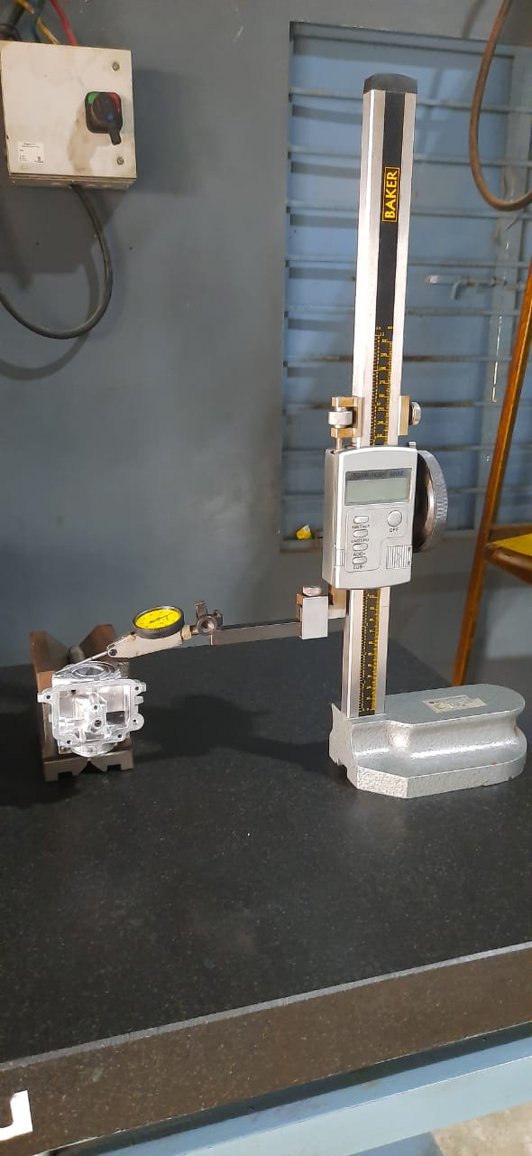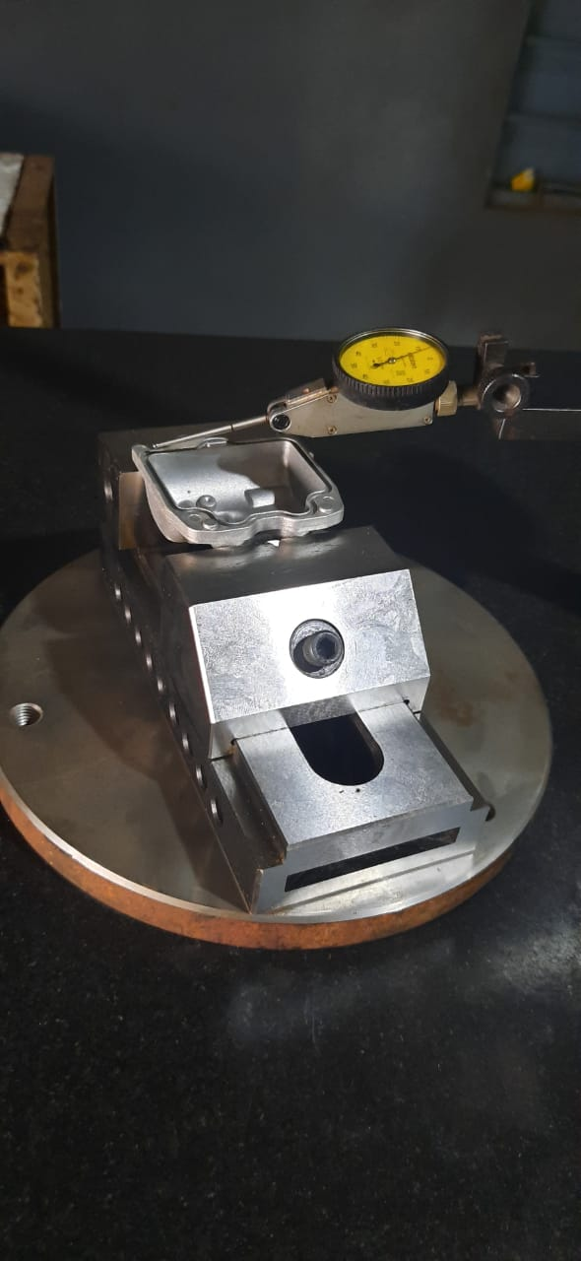
Height Gauge 3 Pin Method

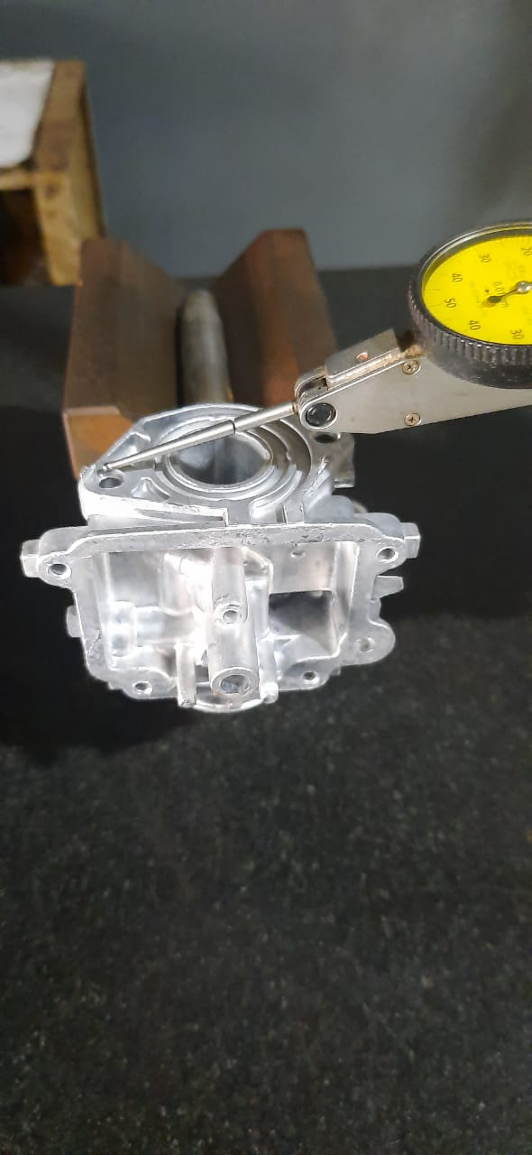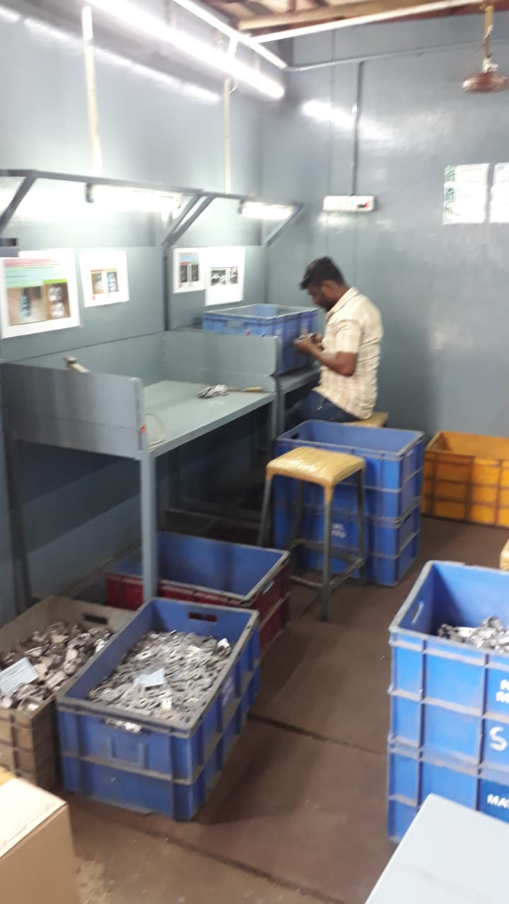
Inspection Area

1. STANDARD CHECKING INSTRUMENTS
2. AIR GAUGE UNIT

FUTURE EXPANSIONS
# | Machinery | Make | Capacity
1 | VMC MACHINE | ACE MICROMATIC
  DTC-400XL WITH
  4th AXIS Feature

Our Valued Customers…

UCAL FUEL SYSTEMS LIMITED PLANT 1,2 & 6 | SUNDARAM FASTENERS LIMITED
EXCEL DIE CASTING | TAG CORPORATION
ASWINI ENTERPRISES (BOSH CUSTOMER) | CASTWELL AUTO PARTS PVT. LTD.
CRP INDIA PVT. LTD. | EBM PAPST INDIA PVT. LTD.
INTERGAL COMPONENTS MANUFACTURE LTD

Contact Us...
Address:
No.99/10, SIDCO Industrial Estate, Thirumudivakkam, Chennai – 600044.
Phone: 044-42815747,9840168560,9840967905 Email: srilakshmi.industries@yahoo.com.

